My new class in September

Welcome to Reception
Class - Owls
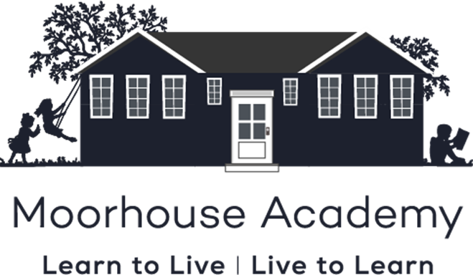

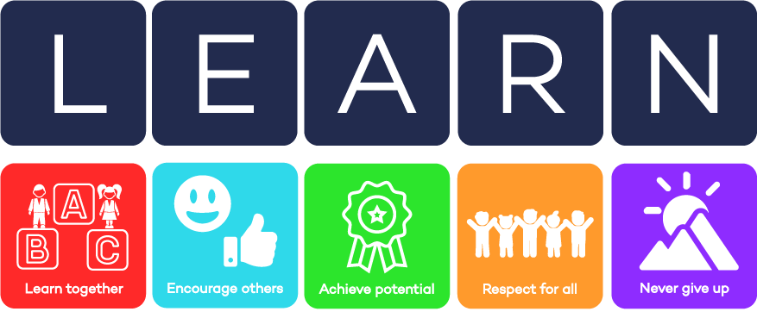
Transition booklet July 2026

Moorhouse Academy
Learn to live, live to learn.
We are a learning community that cares for all
of our children and their families.
We constantly strive to be the best learners and best teachers
we can be in order to make positive contributions
to our local and global community.
We learn to live healthily and happily and love to learn in a fun and caring environment to secure successful futures for all.
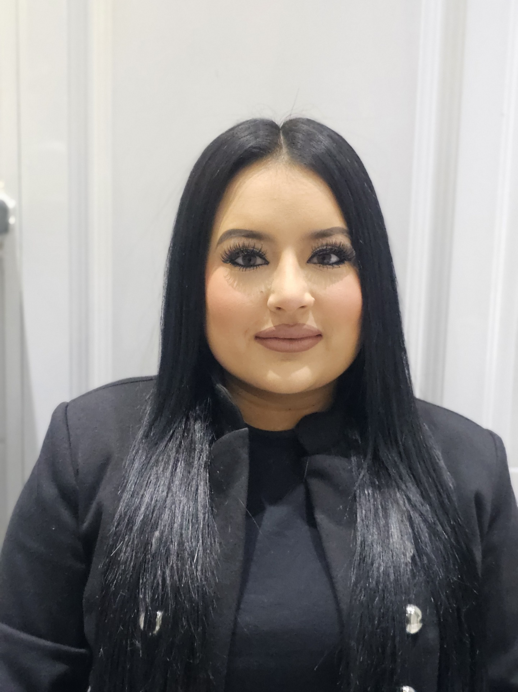
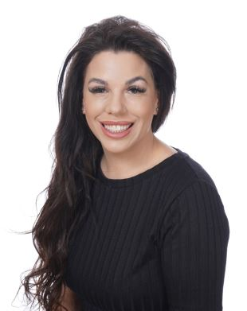

Miss D Cooper
EYFS Lead & Reception Teacher

Miss Hussain
Teaching Assistant

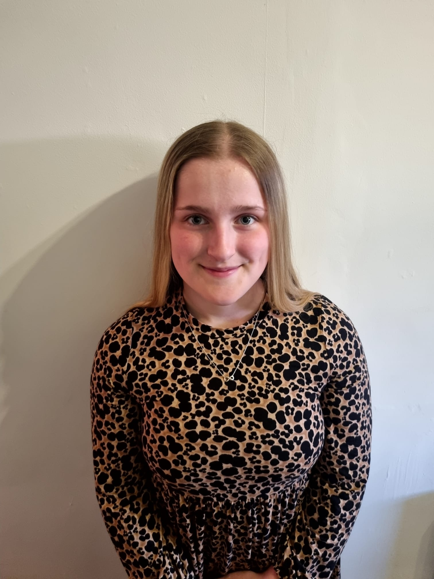
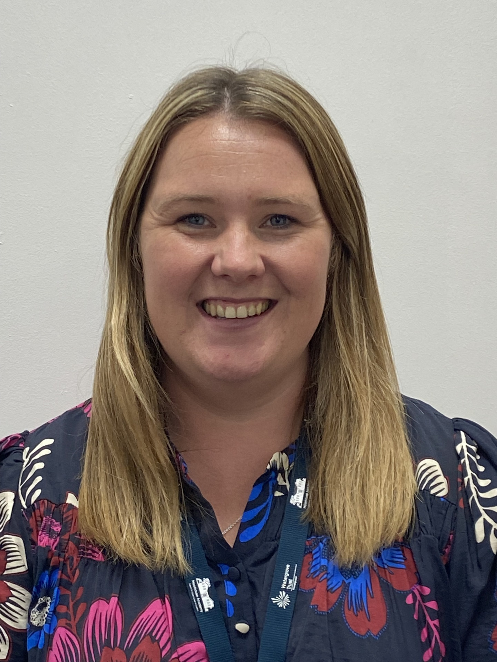
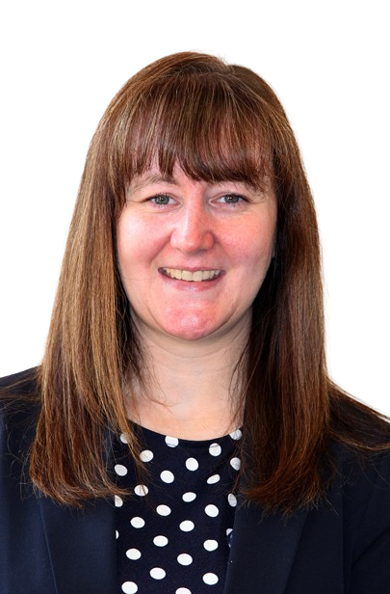
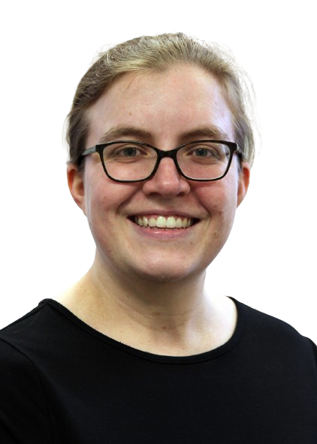


Miss Merrick
Deputy Head
Miss Williams
Teaching Assistant

Miss E Cooper
Nursery Teacher

Mrs Barclay
Teaching Assistant & Pastoral Support

Mrs Milnes
Headteacher

I will be learning about these topics next year:
Marvellous Me  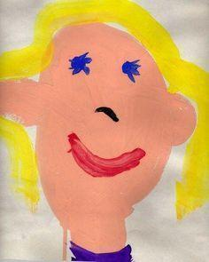  We will be finding out what makes us special. We will explore ourselves, our families and how these can be different to others. | Adventure Awaits  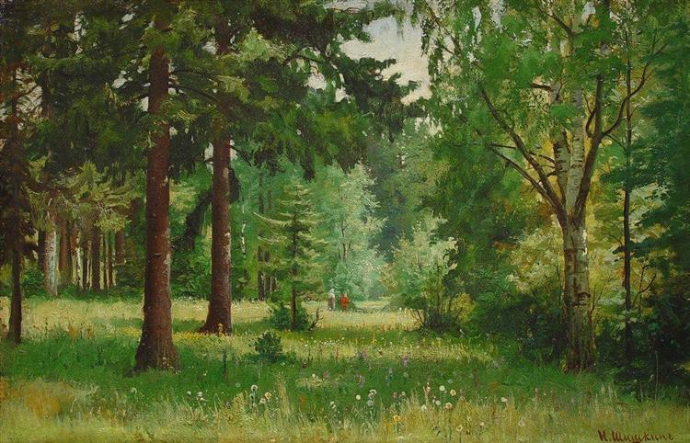  We will discover the world beyond our doorstep as we take adventures into the forest and beyond, studying the world around us and the magic it can contain.
Once Upon A Time  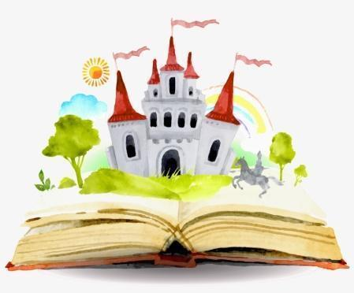  Do you know your fairy tales? We will be entering the world of dragons, fairies, knights and wolves as we read traditional stories and tales. | 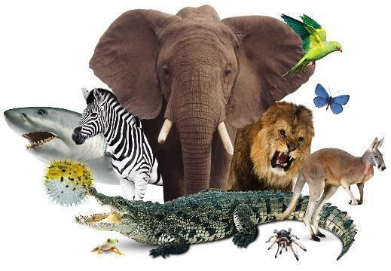  Amazing Animals  From the tiniest mouse to the great, big elephant. We will explore the world of creatures great and small. Let’s discover farms, zoos, jungles and more!
Down at the Bottom of the Garden  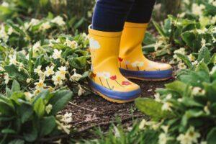  What grows? What crawls? Find your wellies because we will be having fun in the garden. We will watch as plants grow upwards and will be digging down to see what hides beneath the earth! | Sun, Sea, Sand!  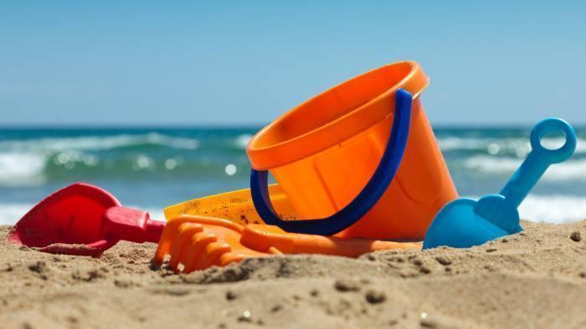  Let’s have fun in the sun! We will dive into the underwater world to explore the creatures that live there. We will set sail with pirates before packing our cases and getting ready for a seaside holiday.
My New Classroom
Dough Area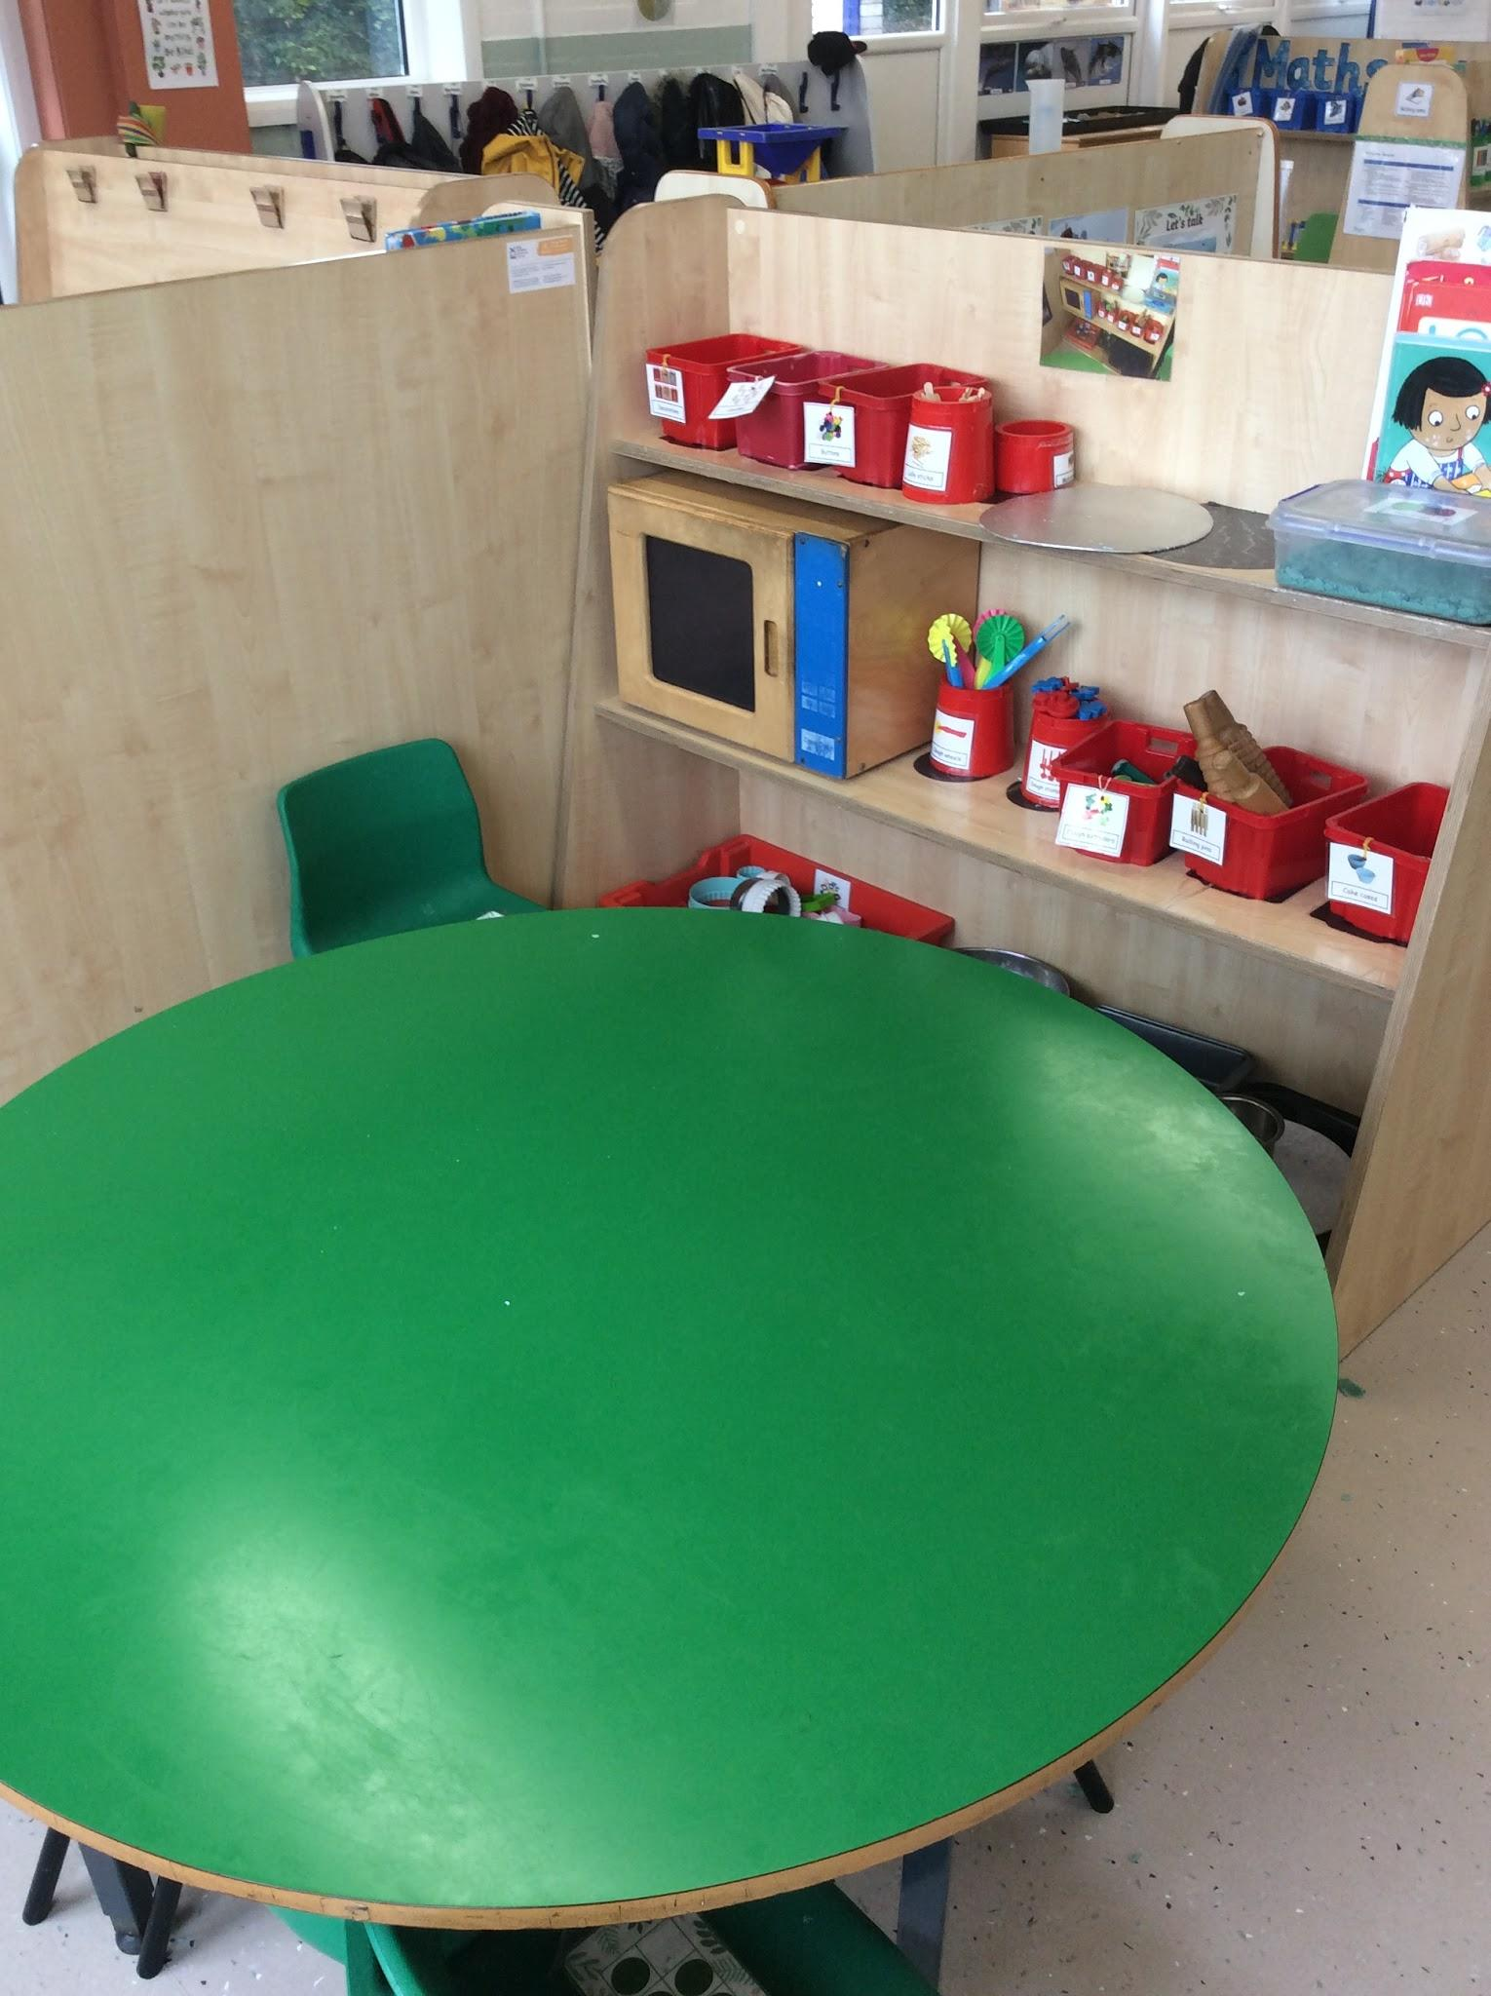 | Water Area  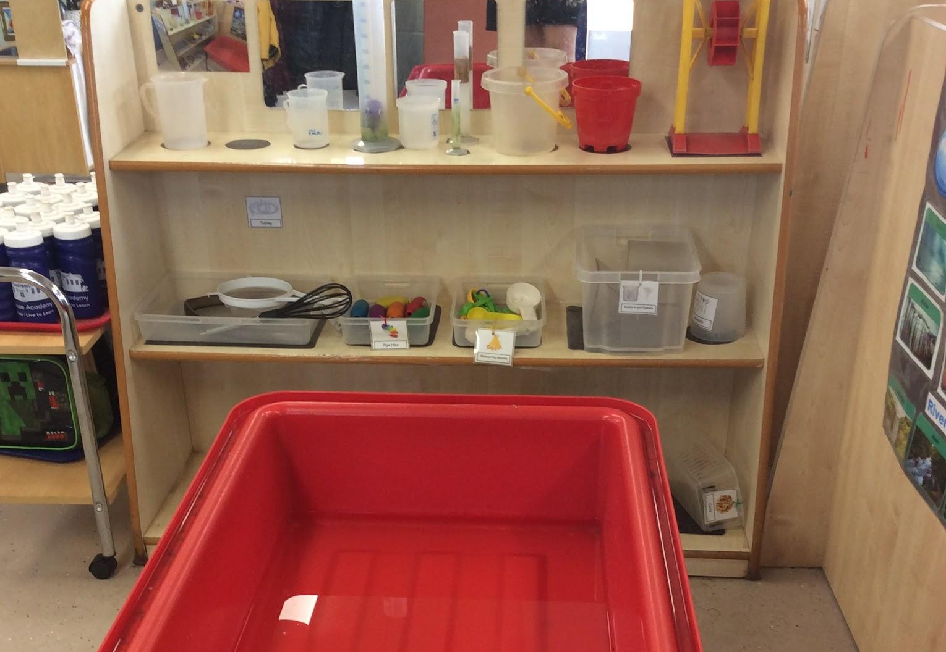
Maths Area  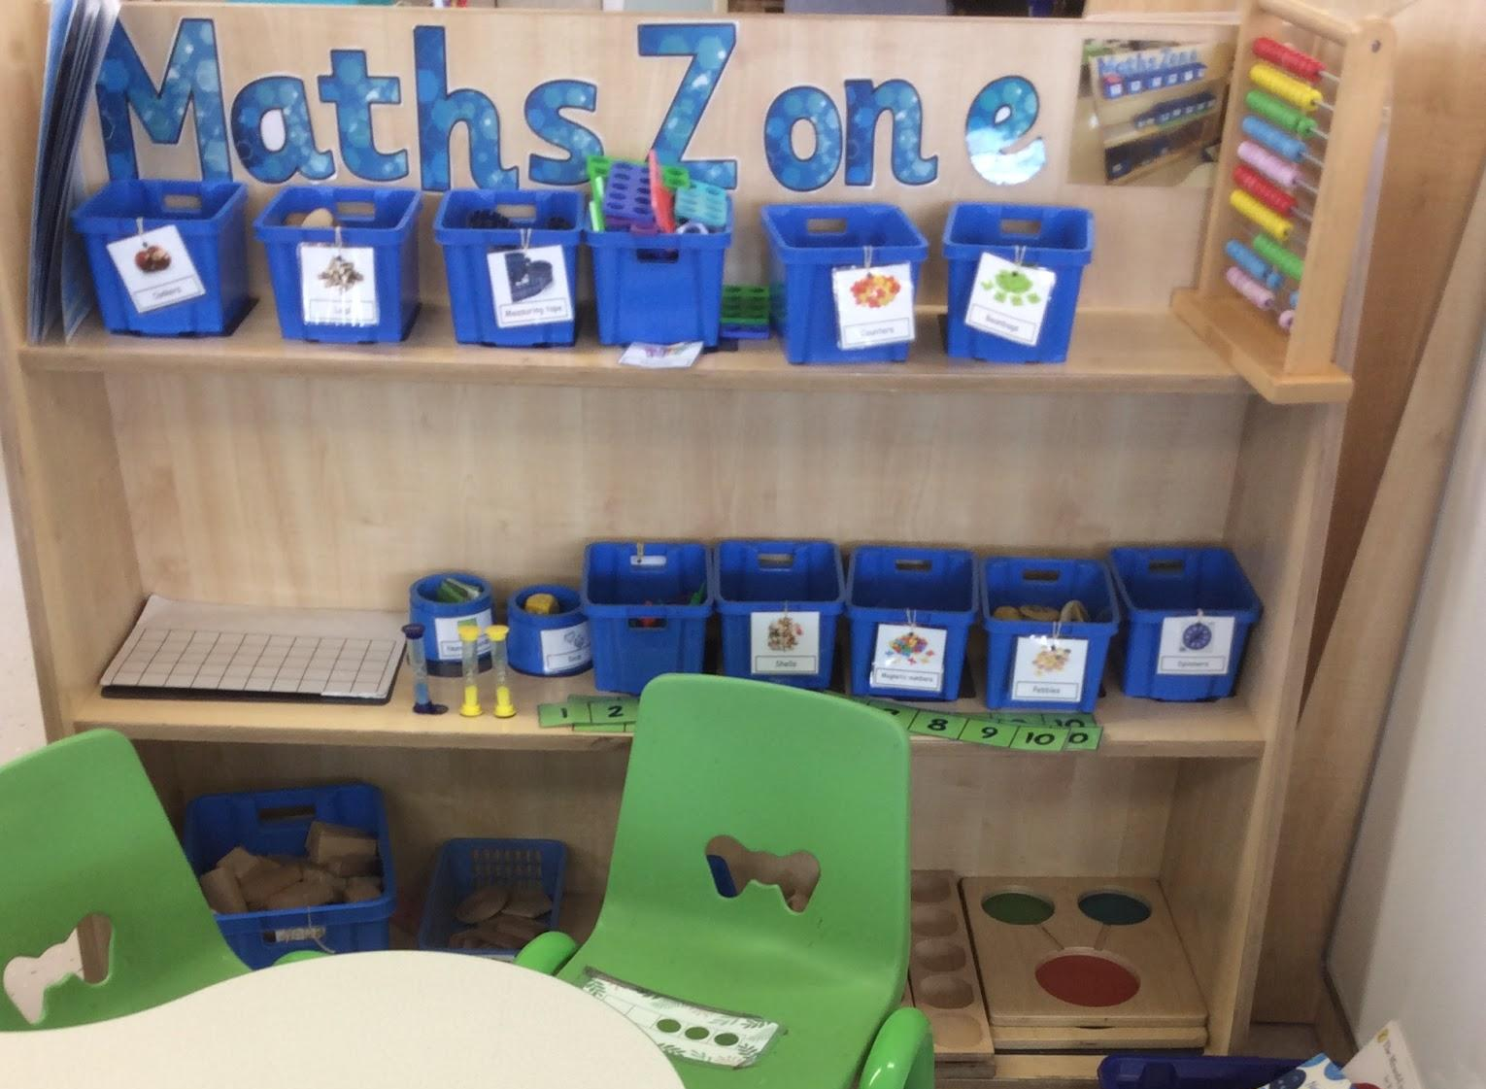 | Creative Area  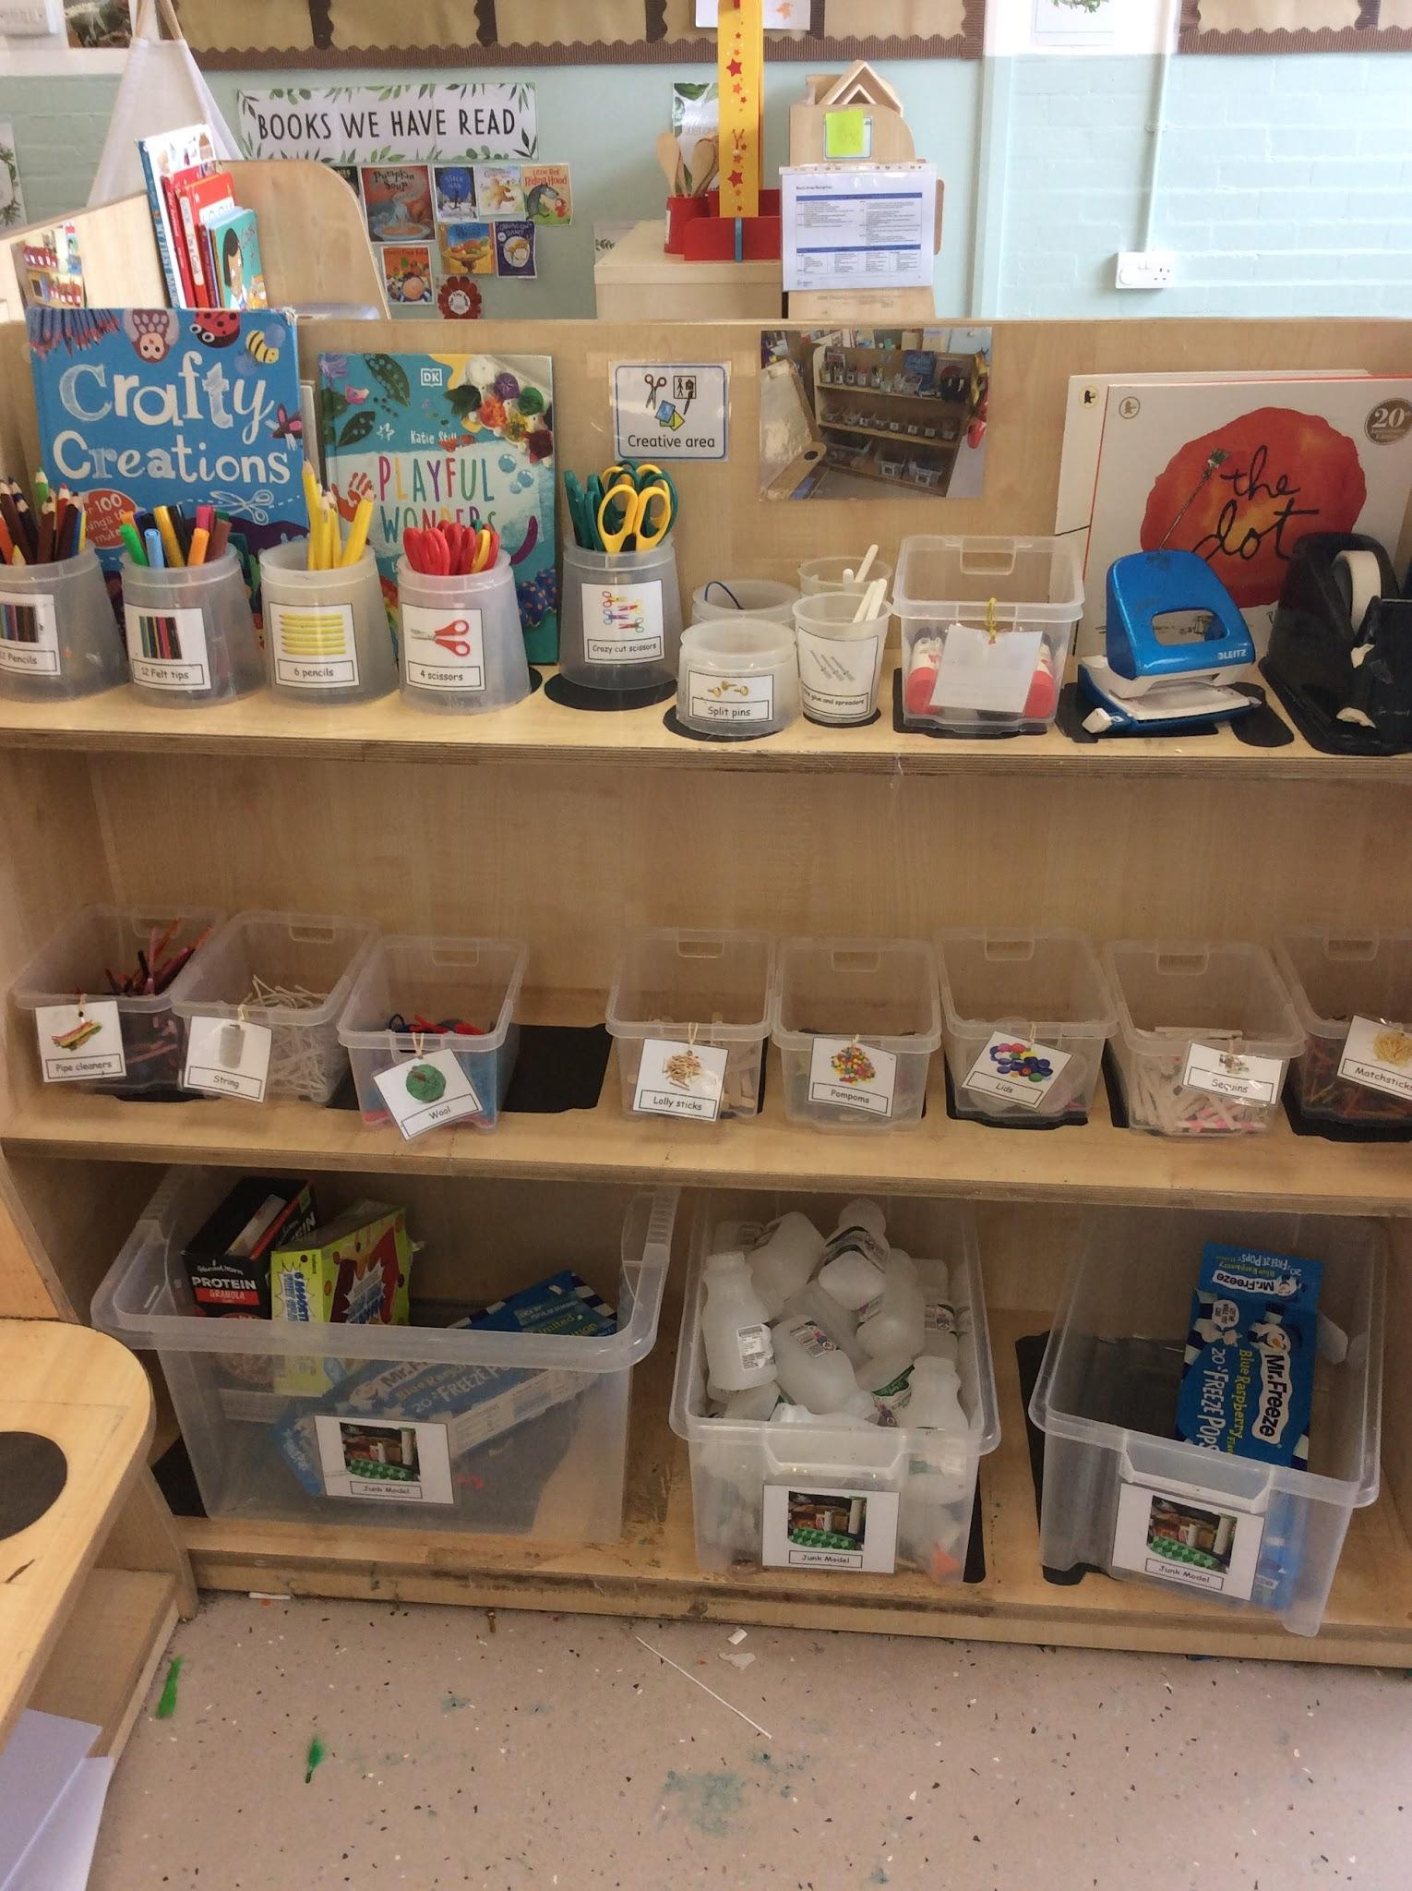
Writing & Mark Making Area  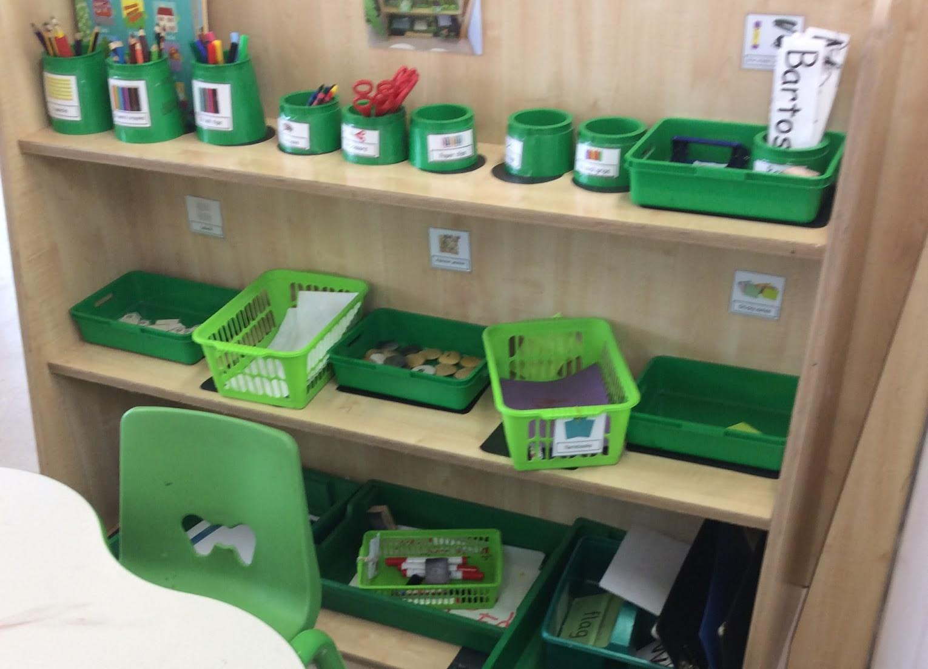 | Construction Area  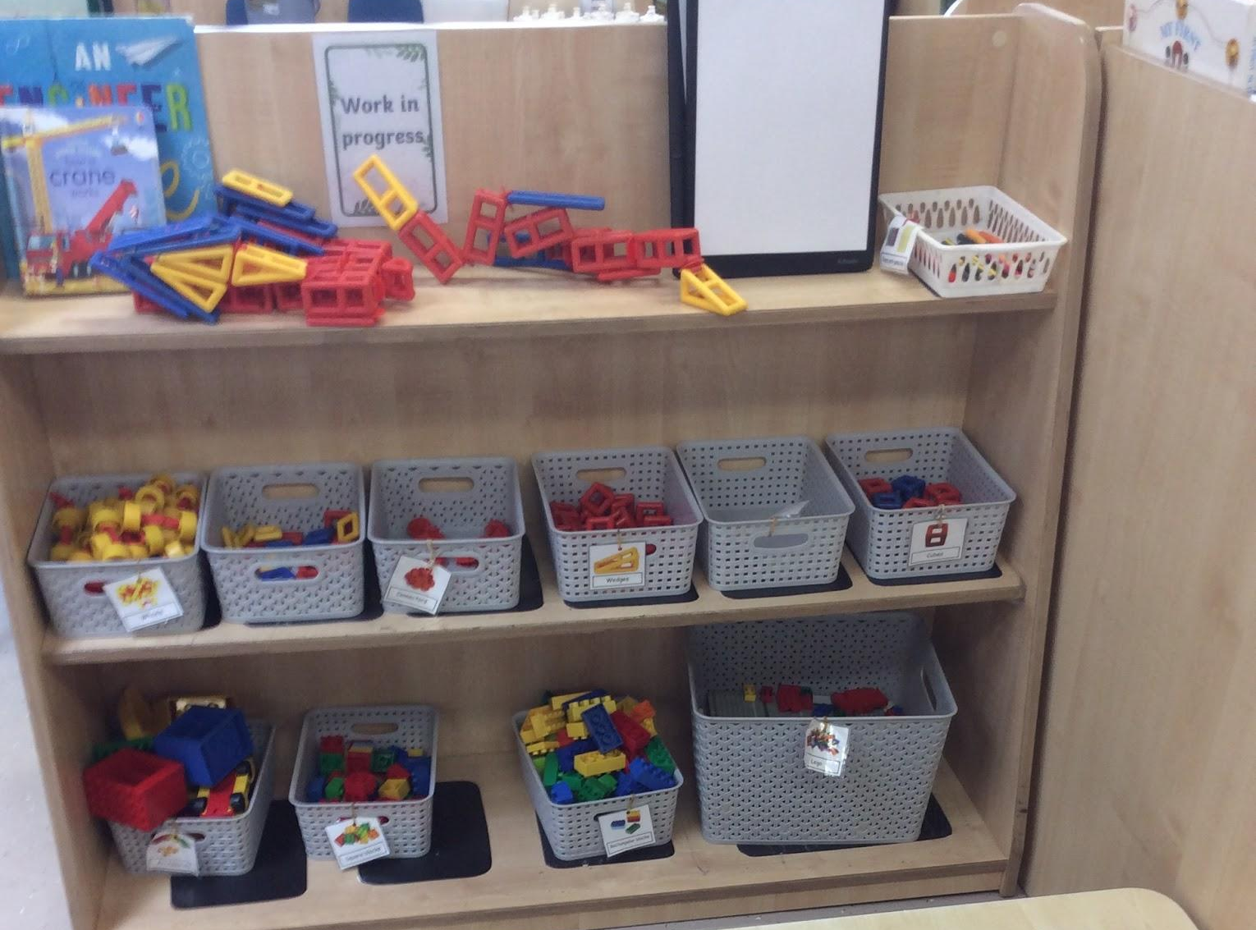

Reading Area  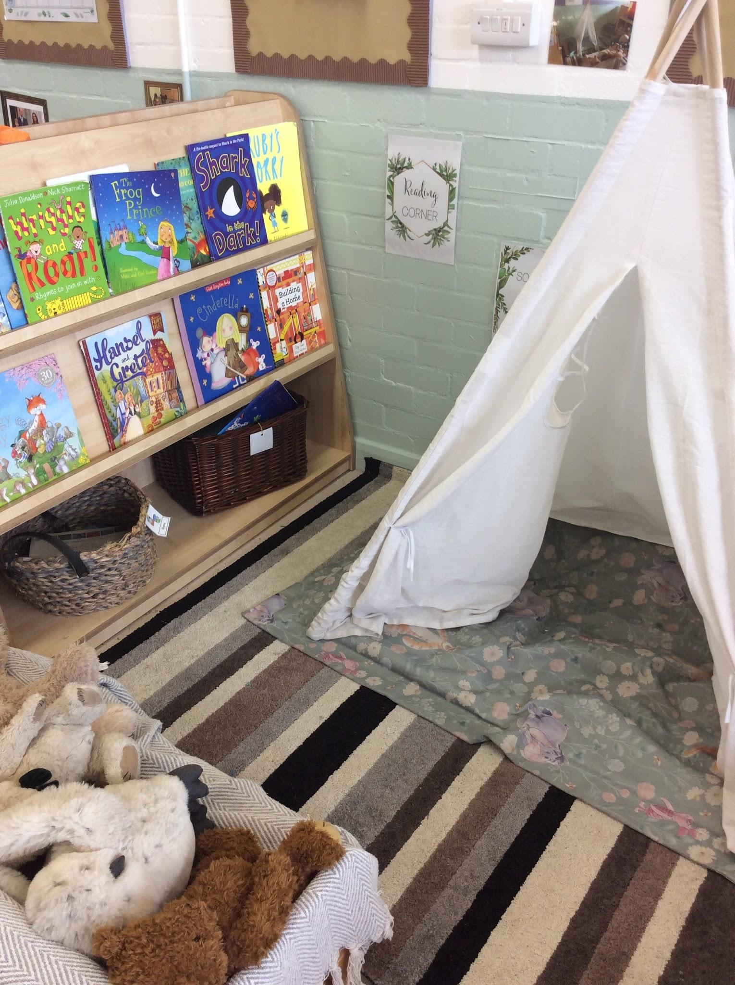 | Home Corner  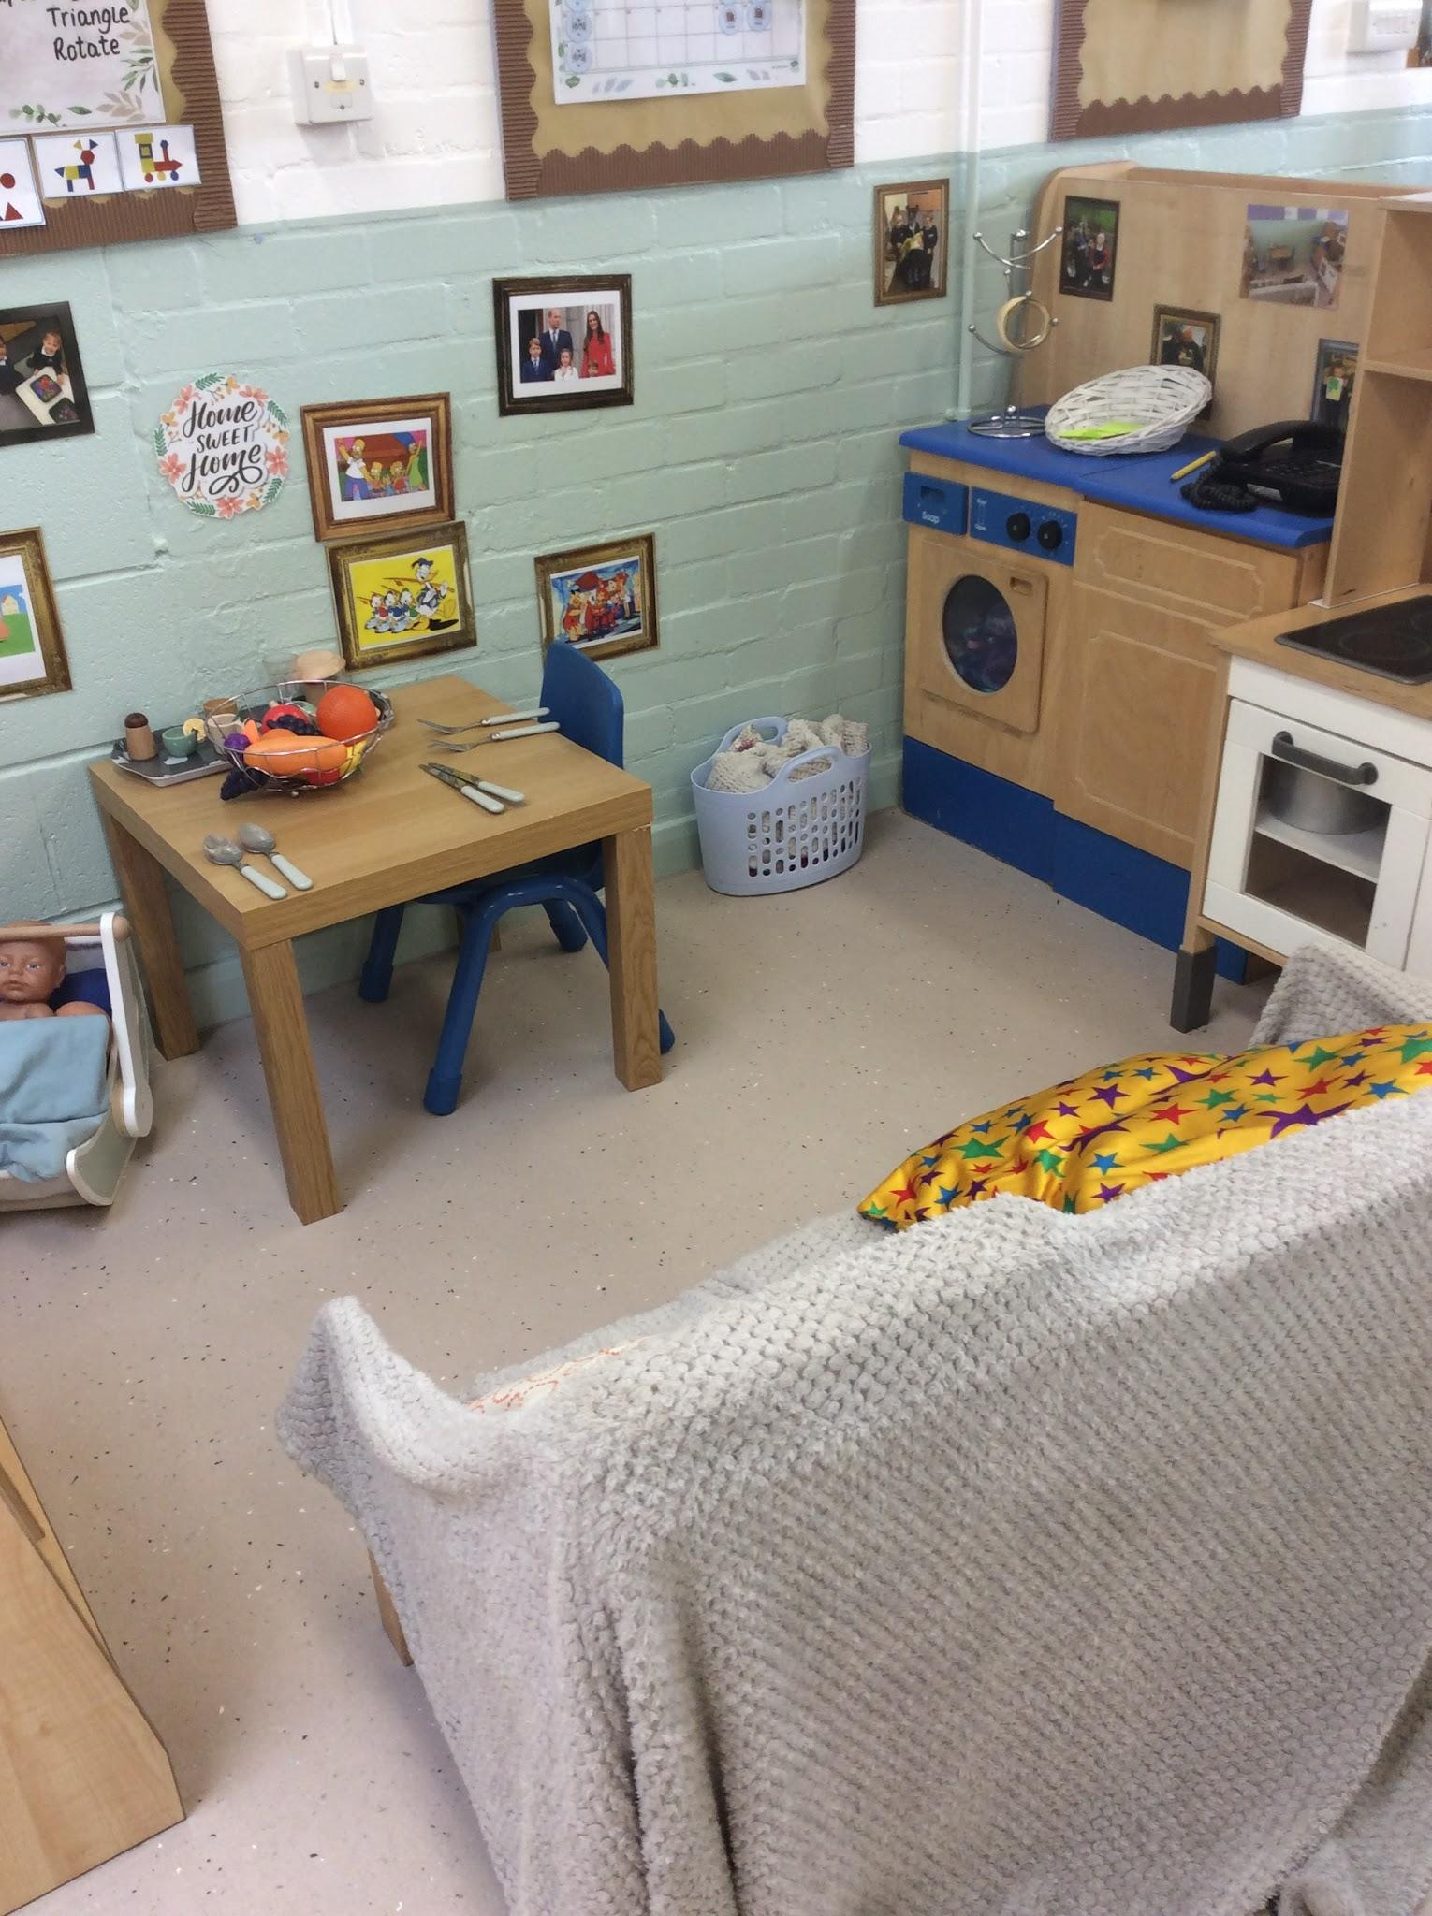
Snack Area  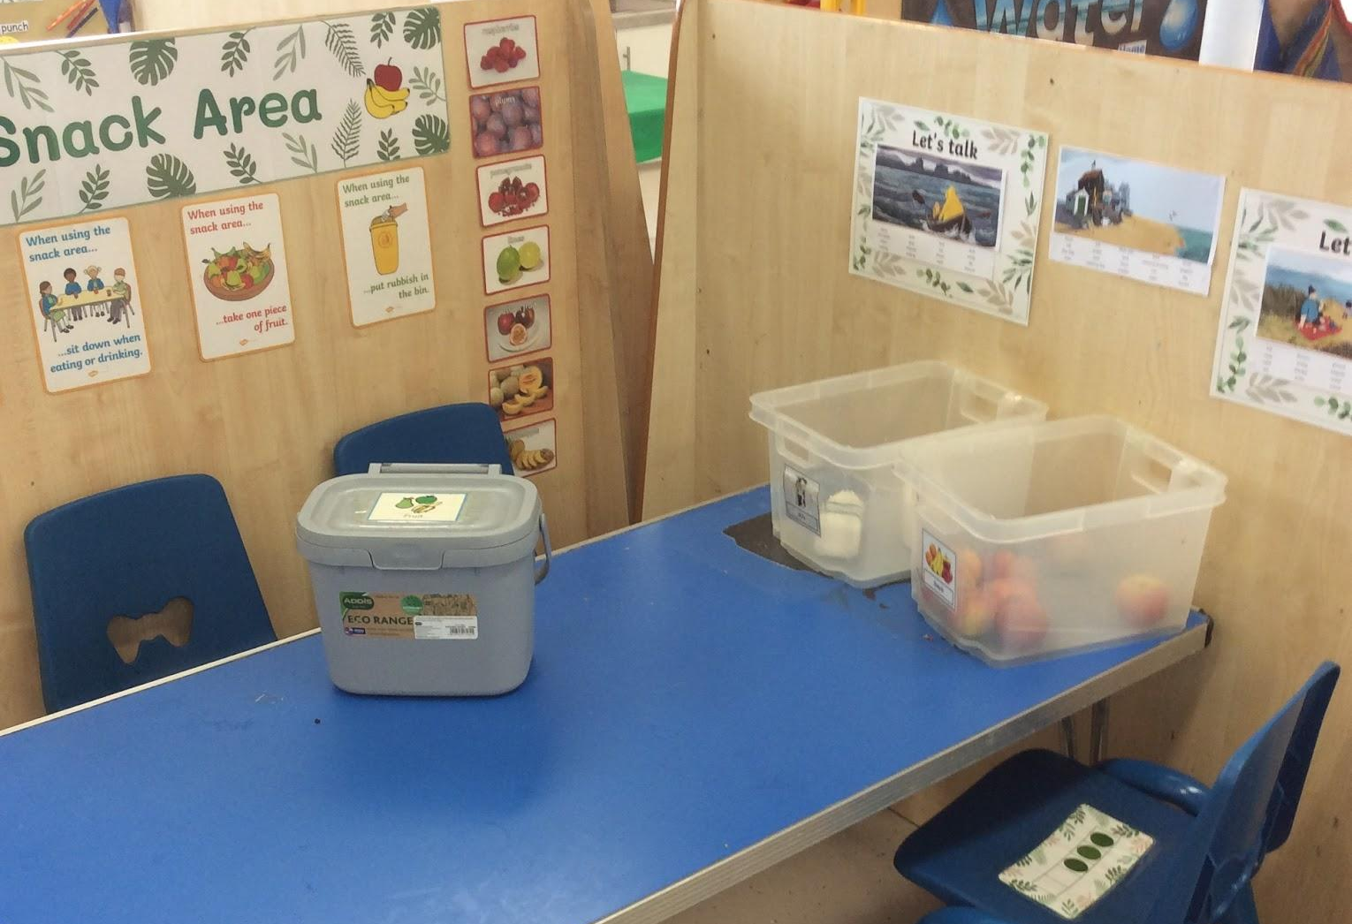 | Block and Small World Area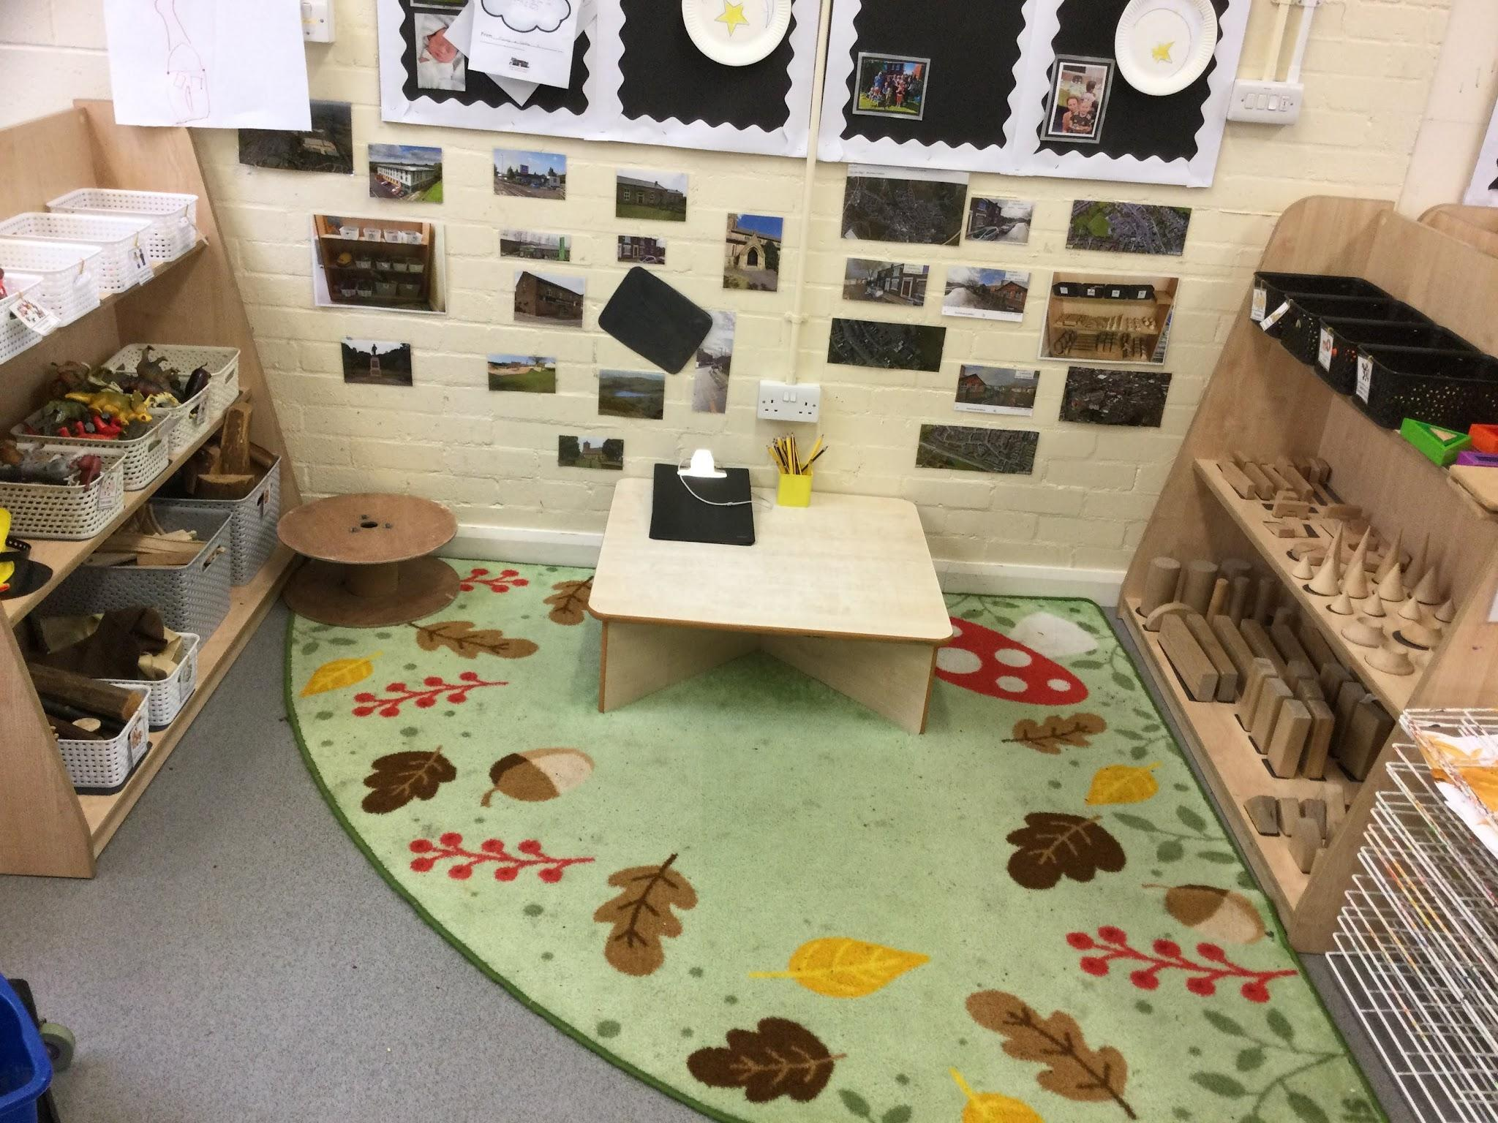
Important information
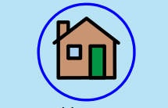
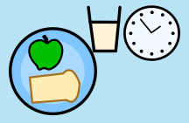
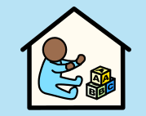
Reception starts at 8.35am  Doors close at 8:45am | Home time is at 3:15pm | Lunchtime is at 12.15am
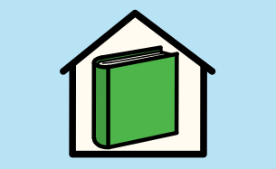  Book Share books are changed on a Monday. | 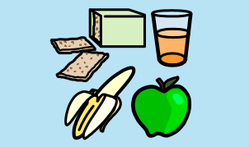  We have rolling snack and you can choose to have it whenever you want. | 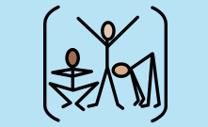  PE is on a Monday afternoon.
Things you will need:
- Clean and smart school uniform with sensible shoes. No jewellery (except watch and small stud earrings) and no extreme hair-cuts. Long hair must be tied back. Make sure your name is in everything!
- A pair of wellies and spare clothes to keep in school
- Your book share book (and reading bag).
- A packed lunch if you are staying all day
- Readiness to learn
- Your very best behaviour
- A big smile!
Things you do NOT need (please leave these at home):
- Stationary or pencil cases (all pens and pencils will be provided by school)
- Large school bags
- Any toys or other personal belongings
Things you and your family can do at home to make school easier:
- Read together every night at home
- Complete your homework on time
- Play - and have fun talking and exploring new things together
- Practise skills such as taking your coat off and putting it on and putting your own shoes on
- Remember, you must be supervised before school starts in the morning.

