My new class in September

Welcome to year 1
Class- Green Finches


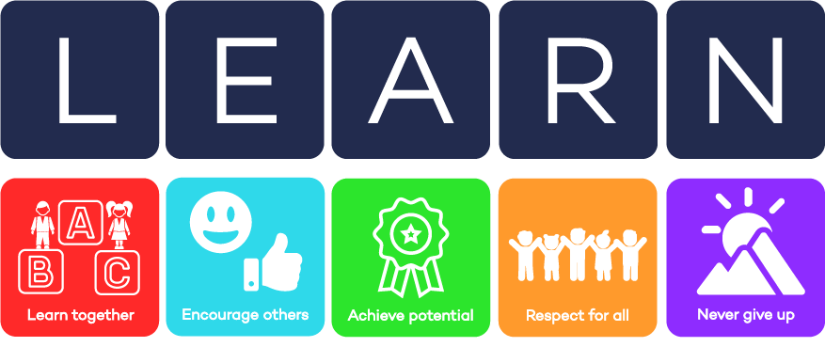

Transition booklet July 2024

Moorhouse Academy

Learn to live, live to learn.
We are a learning community that cares for all
of our children and their families.
We constantly strive to be the best learners and best teachers
we can be in order to make positive contributions
to our local and global community.
We learn to live healthily and happily and love to learn in a fun and caring environment to secure successful futures for all.
Mrs Lee


Other people in school who will keep me safe and help me learn
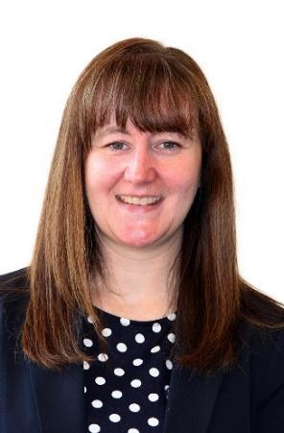 | 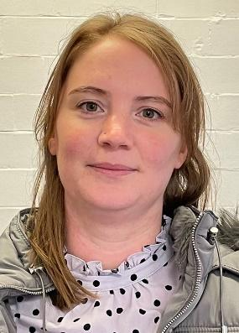 | 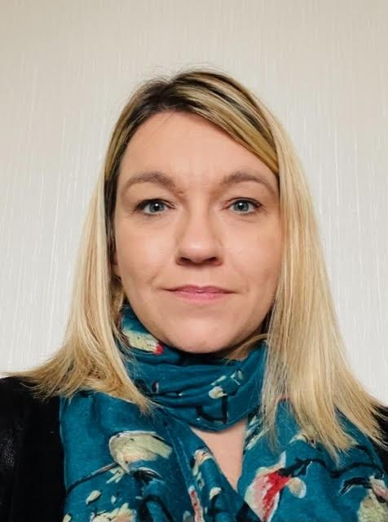 | 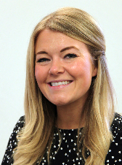
Mrs Milnes  Designated Safeguarding Lead | Mrs Gachette  Deputy Safeguarding Lead | Mrs Tustin  Deputy Safeguarding Lead | Mrs Lishman  KS1 Lead

I will be learning about these topics next year:
How am I making history?  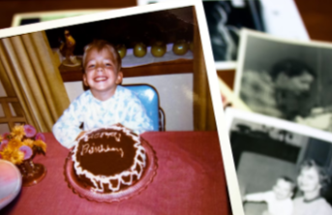  - To develop an understanding of personal chronology.  - To learn more about my history.  - To explore how we remember events.  - To find out what childhood was like for our parents and grandparents.  - To compare childhood now with childhood in the past.  - To identify that some things change and some things stay the same. | What is it like here?    - To locate the school on an aerial photograph.  - To create a map of the classroom.  - To locate key features of the playground.  - To draw a simple map.  - To investigate how we feel about our playground.  - To create a design to improve our playground.
How have toys changed?  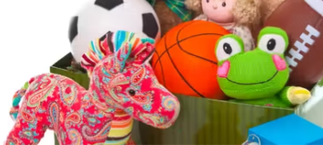  - To discuss a favourite toy.  - To find out what toys our parents and grandparents played with.  - To investigate what toys were like up to 100 years ago.  - To compare toys from the past with modern toys.  - To investigate how teddy bears have changed over time.  - To know how toys have changed over time. | What is the weather like in the UK?    - To locate the four countries of the UK.  - To identify seasonal changes in the UK.  - To identify the four compass directions.  - To investigate daily weather patterns.  - To identify daily weather patterns in the UK.  - To understand how the weather changes with each season.
  How have explorers changed the world?  - To know what an explorer is.  - To recognise the achievements of different explorers.  - To record events on a timeline.  - To use photographs to find out about the past.  - To describe the significance of some people and events within history. | What is it like to live in Shanghai?    - To recognise physical and human features.  - To draw a sketch map.  - To name and locate some continents on a world map. To identify physical and human features of a non-European country.  - To describe what it is like in Shanghai.  - To compare Shanghai to a small area of the UK.

My New Classroom

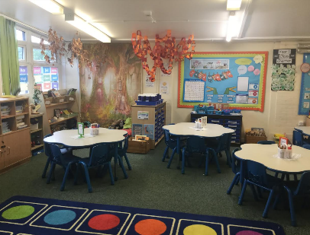  My new classroom | 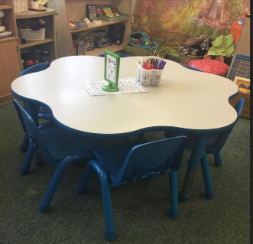  I may sit here | 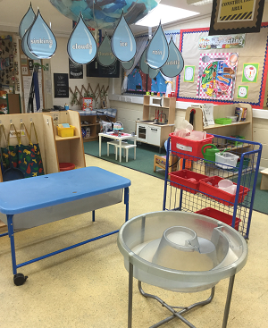  Choose your own learning
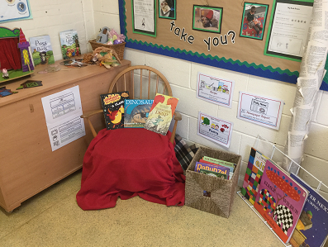  Choose your own learning | 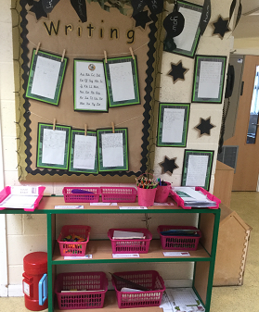  Choose your own learning | 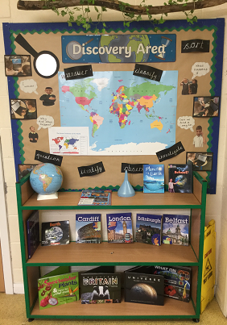  Choose your own learning
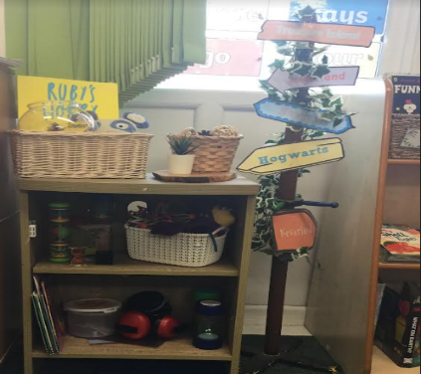  Our calm space | 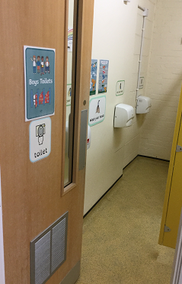  Toilets | 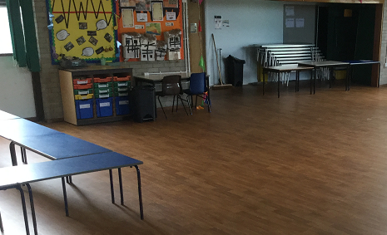  Lunch Hall

Important information
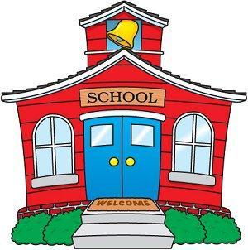  School starts at 8.35am Doors close at 8:45am.  Late arrivals please go to the office. | 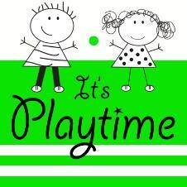  Break time is at 10:45am | 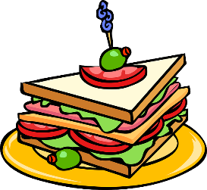  Lunchtime is at 12:15pm
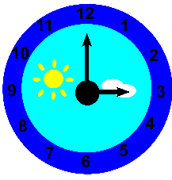  Home time is at 3:15pm.  Late collection please go to the school office. | 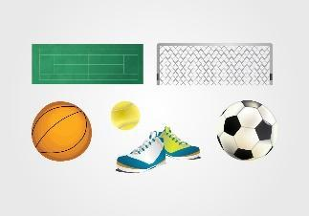  Our PE days are TBC |   Homework comes home on Fridays and is due back in school on Wednesdays.

Things you will need:
- Clean and smart school uniform with sensible shoes. No jewellery (except watch and small stud earrings) and no extreme hair-cuts. Long hair must be tied back.
- PE kit (Navy shorts, navy joggers, plain navy T-Shirt and pumps.) Make sure your name is in everything!
- Your reading book (and reading bag) every day
- A big smile!
- Readiness to learn
- Your very best behaviour
- Packed lunch if you are not having a school dinner

Things you do NOT need (please leave these at home):
- Stationary or pencil cases (all pens and pencils will be provided by school)
- Mobile phones
- Large school bags (small PE kit bag only)
- Any toys or other personal belongings (unless agreed with the class teacher)

Things you and your family can do at home to make school easier:
- Read every night at home (practice makes perfect!)
- Share your spellings at home and practise them together
- Do your homework regularly
- Remember, you must be supervised before school starts in the morning.

