Summer Term SEND Newsletter 2023/24
Welcome to our Summer SEND Newsletter! Each term we will send out our newsletter which will include information relating to SEND.

This term, I thought it would be useful to look at sensory needs. When you have long breaks from school and unscheduled days it’s important to establish a predictable routine that works for your child and your family. With the summer holidays approaching, it may be useful to look ahead and build a schedule for your whole family, which could include whole body sensory rich activities; these are great for both adults and children. It is estimated that 99.9% of children benefit from a clear schedule during their day-to-day activities, especially whilst out of school. We know each child is an individual and it is impossible to provide a ‘one size fits all’ option. What we do know is that sensory rich activities can really help with self-regulation. Here are some ideas you might want to consider in your daily routine. We hope you find it helpful.

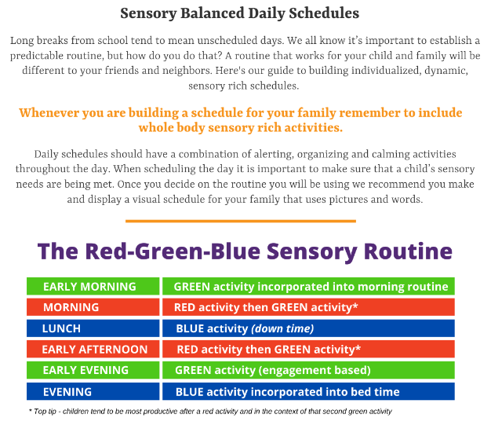
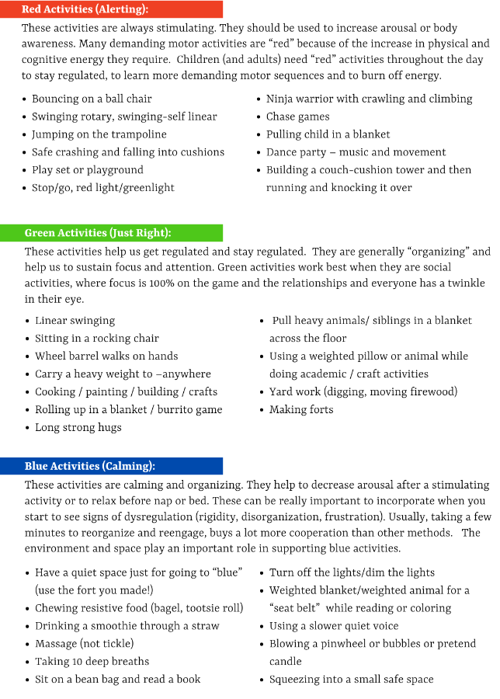

SEND- Graduated Approach
At Moorhouse Academy we follow a Graduated Approach when identifying and deciding the level of SEND Support any child needs.

We use Wave 1, 2 and 3 to support decision making on the level and nature of support required.
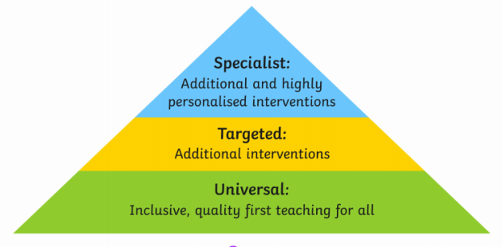

Step 1. Every term, teachers and support staff complete an Identification of Need document to map the varying levels of need within their class. SEND and additional needs are banded into 3 stages; A, B and C.

Stage C- Monitoring pupils who are raising concerns in any of the 4 areas of development and learning. Pupils are placed on the school Monitoring Register. All communication to parents comes from the class teacher.

Step 2. Making a decision to escalate support onto the SEND Register, following the Assess Plan Do Review cycle of at least 1 term. If pupils have made good progress with Wave 1 interventions, they are taken off the monitoring register. If not, and substantial evidence is provided, they are then escalated to the School SEND Register.

This is Stage B. Providing pupils with more targeted and additional intervention or support. Pupils at Stage B are on the school SEND Register. Referrals may be made to external services.

Communication is frequent with parents to keep them updated on the process, from initially the class teacher and, where required, the SENDCO.

Step 3.
Stage A. Pupils at this stage have the highest level of SEND. Implementing the right support, planning provision, reviewing impact and then starting the Assess, Plan, Do, Review cycle again. Additional support and intervention is embedded, pupils have a school support plan in place and may have an Education Health Care Plan. Communication with parents is frequent but formally at least once a term.

