Spring Term SEND Newsletter 2023/24

Welcome to our first SEND Newsletter! Each term we will send out our newsletter which will include information relating to SEND.

What can I do if I think my child has SEND?

Mrs Kerry Tustin is the school Deputy Head Teacher and SENDCo (Special Educational Needs & Disabilities Coordinator). If you have any concerns regarding your child’s special needs, your first port of call is to speak with your child’s class teacher. They see your child every day and have a good idea of the strengths of your child. Please see the ‘graduated response’ information at the end of this newsletter.

Special educational needs, often referred to as ‘SEN’ or ‘SEND’ (Special educational needs and disabilities), is a term used to describe learning difficulties or disabilities that make it harder for a child to learn compared to children of the same age. All children may experience challenges with their learning at some point and for most children, these difficulties are overcome with support from teachers and home. However, children with SEND are likely to need extra or different help to be able to learn.

How do you know if a child has SEND?

A child or young person has SEN if they have the following:
- they have significantly greater difficulty in learning than the majority of other children and young people the same age
- they have a disability which prevents or hinders them from making use of facilities of a kind generally provided for others of the same age in mainstream schools or mainstream post-16 provisions

A child or young person has a disability if they have the following:
- they have a physical and mental impairment which has a substantial and long-term adverse effect on their ability to carry out day-to-day activities.

What types of difficulties are SEND?

Children may have difficulties in one or more of these areas:

Cognition and Learning - A child may find all learning difficult or have difficulties with specific activities such as reading or spelling. A child may have trouble understanding instructions and carrying out tasks. A child may have memory difficulties.

Communication and Interaction – A child may have difficulty in talking to others or under-standing what others are saying to them. A child may have difficulty with interactions with others, such as not being able to take turns. A child who has speech and language needs will be classed as having communication and interaction needs.

Physical and Sensory – A child may have hearing or vision loss. A child may have difficulty with sensory processing, being under or over-sensitive. A child may have a medical condition which affects them physically.

Social, Emotional and Mental Health - A child may display behaviours such as having very low self-esteem or being very anxious. A child may display challenging, disruptive or distressing behaviours. A child may have underlying conditions which affect their mental health.

Coffee and Cake Drop-in Session

Thank you to all who attended our drop-in session. It was a great success! We can’t quite stretch to a weekly meeting just yet but will host a half-termly meeting in school where you can come and chat and meet other parents in a relaxed environment. The next session will be in school on Tuesday, 30th April at 2:30pm.

Seeking advice

Rochdale have access to a wide range of services:
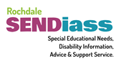
Rochdale SENDiass offer free, impartial, confidential information and advice for Children and Young People aged 0-25, and their parents or carers; where a child or young person has or may have special educational needs or disability.
https://www.barnardossendiass.org.uk/rochdale-sendiass/


Our Rochdale has information on the local offer for SEND, as well as links to different services.
https://www.ourrochdale.org.uk/kb5/rochdale/directory/results.page?localofferchannel=6&localofferagebands=2

Rochdale Council has a range of services where parents, carers and young people can seek support. Please click on the links for more information.

Attached stay connected Our vision is to provide top quality speech and language support to all children and families who need it in a prompt and convenient manner.
Action together we know people can make things happen as we see it everyday. Across Oldham, Rochdale and Tameside, there are thousands of people changing lives, improving neighbourhoods and contributing positively to our area.
Barnardo's Rochdale service works in partnership with Rochdale Borough Council to provide a range of borough wide services for children and young people.
Beyond psychology is a not-for-profit social enterprise, led and founded by chartered clinical psychologists, who use their expert knowledge, scientific research and experience to improve the mental health of children, their families and those that work with them. We have particular expertise in trauma and attachment.
Carers Hub Rochdale provides a single point of access supporting all carers in the Rochdale borough.
Colourful Minds is a non profit organisation providing wellbeing and emotional support for parents and carers of families of all ages with SEN and/or disabilities.
Essential Parent are one of the world’s leading online resources for expert-led, evidence-based parental advice.
Family health link worker service provides continuing holistic support to families of children with complex healthcare needs.
Gaddum is a part of the Thinking Ahead pathway in Heywood, Middleton and Rochdale. Getting Help provides holistic support to help clients overcome barriers in meeting health and social care needs which are impacting on their wellbeing and mental health.
Home start Rochdale and Bury offers practical and emotional support for any family with a child under the age of twelve years old.
Parenting & family relationships programmes give support, advice and guidance to parents and carers living in the borough.
Rochdale Parent Carers Voice are a group of volunteer parents and carers whose aim is to represent the interests of families and young people with additional needs and disabilities from birth to 25 years.
Rochdale Sendiass (special educational needs disability information advice support service) provides free, confidential and impartial information, advice and support.
Rochdale Speech, Language and Communication toolkit is a tool for parents and practitioners providing a range of services and strategies available to children pre-birth to 5 years old.
SHINE parent support group is a 5 week parenting group for parents/carers of children aged 5 and under whose children have social and communication needs.
Support for Carers make a vital contribution to society by giving their time and energy to care for a family member, friend or neighbour.

The Neurodiversity Hub

The Neurodiversity Hub is a multi-agency screening, signposting, and support service.

Who is in the team?

- Speech and language therapists
- Paediatric neurodevelopment nurses
- Neurodiversity liaison nurses
- Specialist teachers
- Local mental health practitioners
- Team Lead for the Rochdale Autism and ADHD service (RAASS)

Working hours: Monday to Friday from 8am until 4pm, excluding bank holidays.

They accept requests for help for children and young people under 19 years of age who live in Heywood, Middleton, and Rochdale. You do not need a formal diagnosis to access support from The Neurodiversity Hub.

Where appropriate, they will work with families and services to gain the evidence required to move forward with referrals for autism/ADHD assessments.
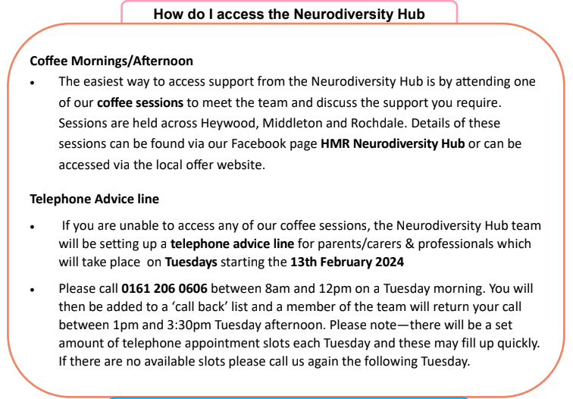

SEND- Graduated Approach
At Moorhouse Academy we follow a Graduated Approach when identifying and deciding the level of SEND Support any child needs.

We use Wave 1, 2 and 3 to support decision making on the level and nature of support required.

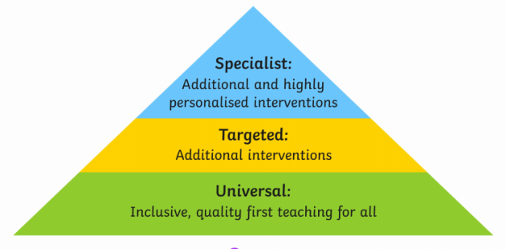

Step 1. Every term, teachers and support staff complete an Identification of Need document to map the varying levels of need within their class. SEND and additional needs are banded into 3 stages; A, B and C.

Stage C- Monitoring pupils who are raising concerns in any of the 4 areas of development and learning. Pupils are placed on the school Monitoring Register. All communication to parents comes from the class teacher.

Step 2. Making a decision to escalate support onto the SEND Register, following the Assess Plan Do Review cycle of at least 1 term. If pupils have made good progress with Wave 1 interventions, they are taken off the monitoring register. If not, and substantial evidence is provided, they are then escalated to the School SEND Register.

This is Stage B. Providing pupils with more targeted and additional intervention or support. Pupils at Stage B are on the school SEND Register. Referrals may be made to external services.

Communication is frequent with parents to keep them updated on the process, from initially the class teacher and, where required, the SENDCO.

Step 3.
Stage A. Pupils at this stage have the highest level of SEND. Implementing the right support, planning provision, reviewing impact and then starting the Assess, Plan, Do, Review cycle again. Additional support and intervention is embedded, pupils have a school support plan in place and may have an Education Health Care Plan. Communication with parents is frequent but formally at least once a term.

